Keep up , Not Catch Up Strategy
Reaching the lowest 20% and Vulnerable learners 2022
Adequate time allocation for all aspects of Letters & Sounds, as appropriate to children’s needs, capacity and context.

Daily QFT session Same day additional practise Interventions Reading
Whole class QFT Daily lesson  (average 20 mins)  Spotlight & Scaffolding to support lowest ability  + frequent practise throughout the day of oral blending & segmenting, GPC flashcard recognition, blending boosters ‘countdown.’  Revise key aspects that need reinforcement.  Strong AFL to secure learning in the moment + that day for key children.  Target vulnerable learners.  Direct line of vision, near an adult, close monitoring +AFL. | Same day in class intervention  Short, sharp precise focus  (5 mins approx)  Identify children 1-1/key groups in need of same day in class additional practise.  GPC recognition  Blending cccvc’s (blending 3 sounds at the beginning of words)  Blending using ‘oa’  Etc....  .  Not just a lesson re-run!  Continuous consolidation of phonics in the setting. Must do job of the day, directed tasks and frequent practise. For example, early morning work: Phonic task, i.e write what you see. Use and apply prior day’s phonemes. Meanwhile TA’s have SEN 5 min phonics 1-1/1:2 intervention.  Targeted additional practise of precise skill GPC’s or blending with certain phonemes, perhaps the new phoneme introduced that day.  R/YR1: Same day large group additional practise: i.e, 5 mins after lunch. Year 2:Higher ability complete an independent use and apply challenge. Key aspects are revisited to secure children ‘keep-up’.  AFL used to pin point exact needs of vulnerable learners or SEN who need 1-1 5 mins (i.e immediately before lunch or at set time).  This works well because: Daily QFT secures learning and addresses any misconceptions/ difficulties that day.  Vulnerable learners are under the ‘Spot light ‘ and constant use of assessment to swiftly address needs in the moment, and later that day.  Practise sessions and interventions are daily, short, precise and address a gap.  Staff highly trained and use tracking effectively to meet a child’s precise needs. | - Precision intervention  (5 mins )  Plan, target and track those in need of 1-1 precision intervention: Mix it up blending, win it GPC’s recognition, etc.  Correct pitch so learning is targeted to a precise gap.  5 mins per child more effective than 15 mins large challenging group.  Target and Track: Rapid Phonics Intervention Map  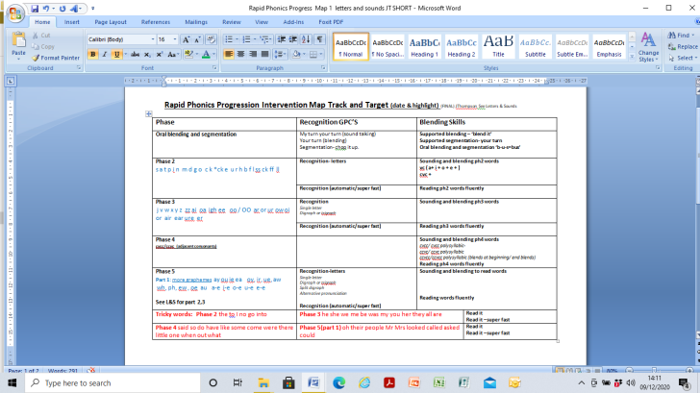
You noticed in the lesson, some chn don’t grasp blending 3 consonant clusters at the beginning or grasp a particular few digraphs so you are going to address this to be achieved by end of the day.

Another school, divide their class into 2 large groups. Teacher and TA do an additional 5 min practise – blending booster or GPC to ensure they keep-up. Pitched at different levels.

Some schools do a daily ‘blending boost’ and ‘countdown’ to rapid read GPC’s like a mini Revise and Review but with a focus on new phoneme taught that day or a precise gap.
Pre-teaching the next day’s phoneme to key groups is another keep-up method.
Summary:

Keep up, not catch up to support our lowest attainers

- Children in key positions in class
- Strategic use of adults to support key children
- Scaffolding skills used with precision and skill...
- Assessment for learning (AFL) used effectively to adjust, revise key learning in the lesson + follow-up practise that day.
- Daily short sharp phonics additional daily practise to revisit what is required that day. Not a lesson re-run.
- Systematic 1-1 intervention to address a precise gap.
- Monitoring and analysis to ensure they succeed in every part of the lesson.

See ‘Scaffoling skills’ to support the less able.

