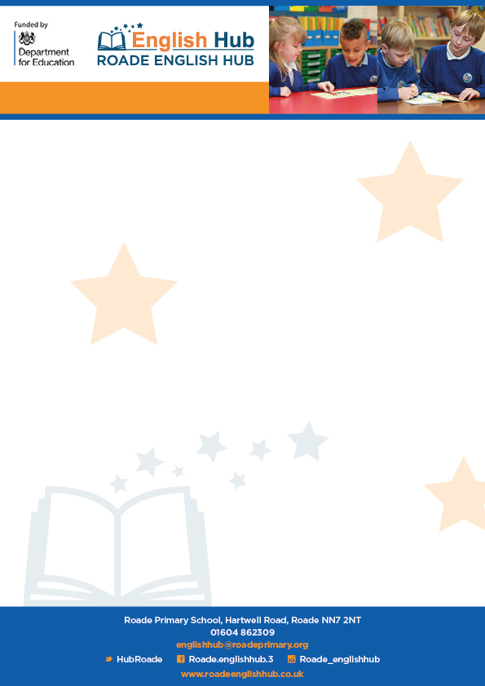

**Free e-reader books and reading for comprehension**

Fully decodable texts can be found by following this link

[Free eBook library | Oxford Owl from Oxford University Press](https://www.oxfordowl.co.uk/reading-owl/find-a-book/library-page/)

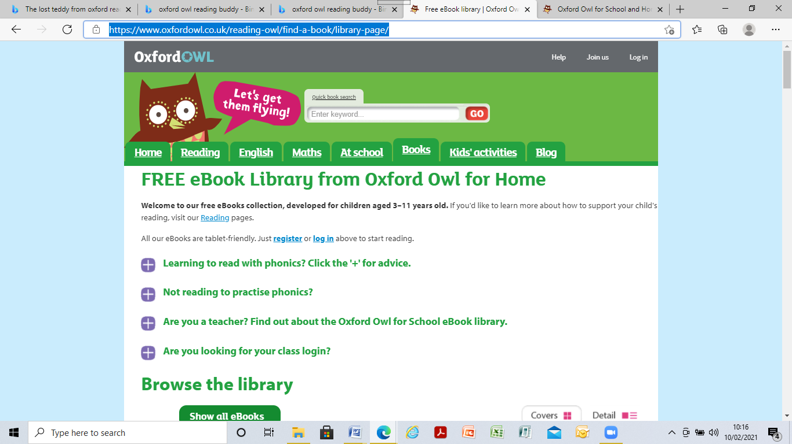

The Oxford Reading Buddy is great for digital reading, teaching and assessment for love of reading. There are comprehension quizzes at the end of a book, as well as quiz scores track progression. It is well priced, so good value for money.

<https://www.oxfordreadingbuddy.com>

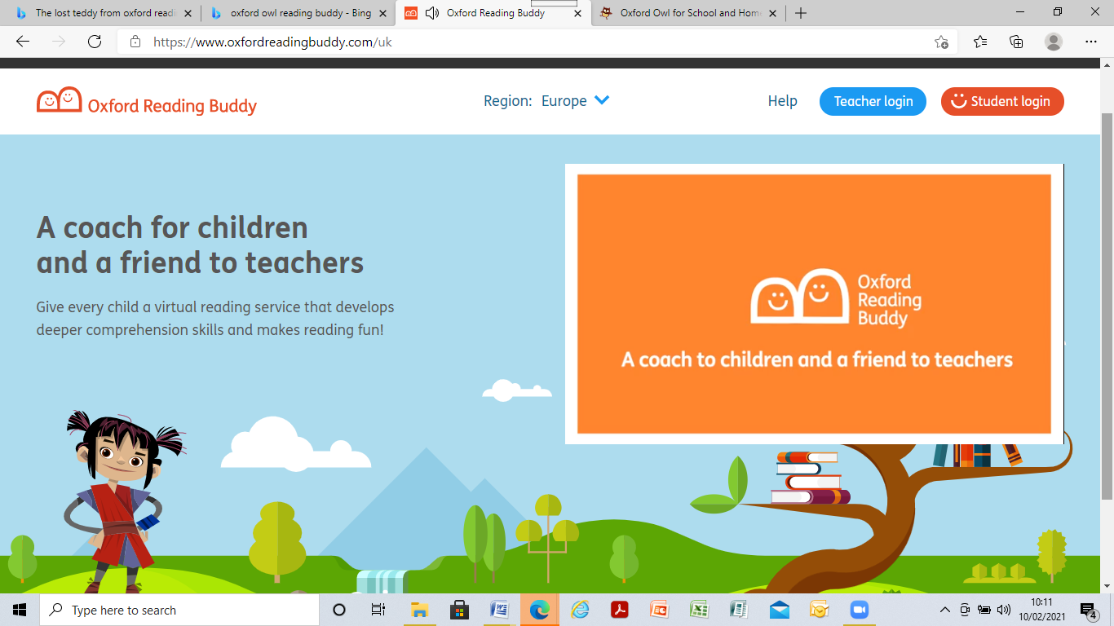

To have a look at how the website site works, please use the link below.

[Oxford Reading Buddy Platform Walkthrough - Bing video](https://www.bing.com/videos/search?q=oxfprd+owl+buddy+readers&docid=608009555551060961&mid=AE214D8A1ACACA0C89D0AE214D8A1ACACA0C89D0&view=detail&FORM=VIRE)

**Oxford Owl Reading**