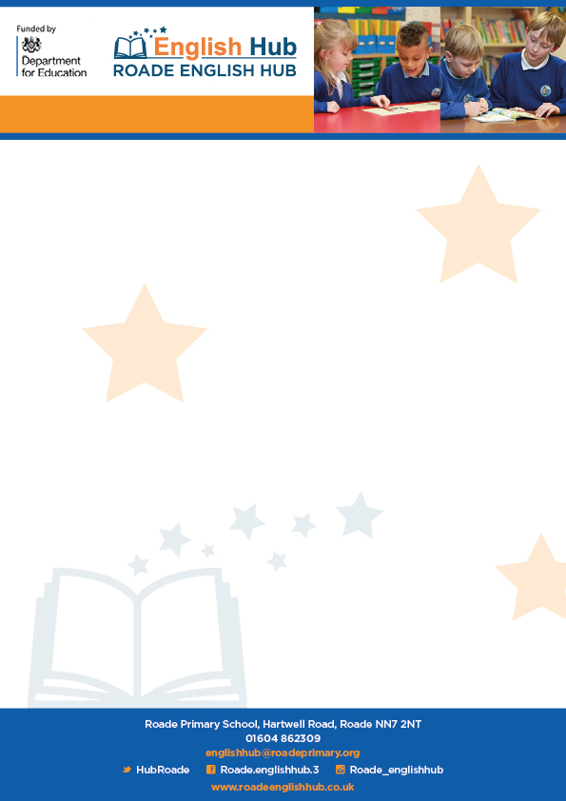

**Phonics Parent guide & How to say the sounds**

As a parent if you are unsure of the correct sounds please have a look at these wonderful resources.

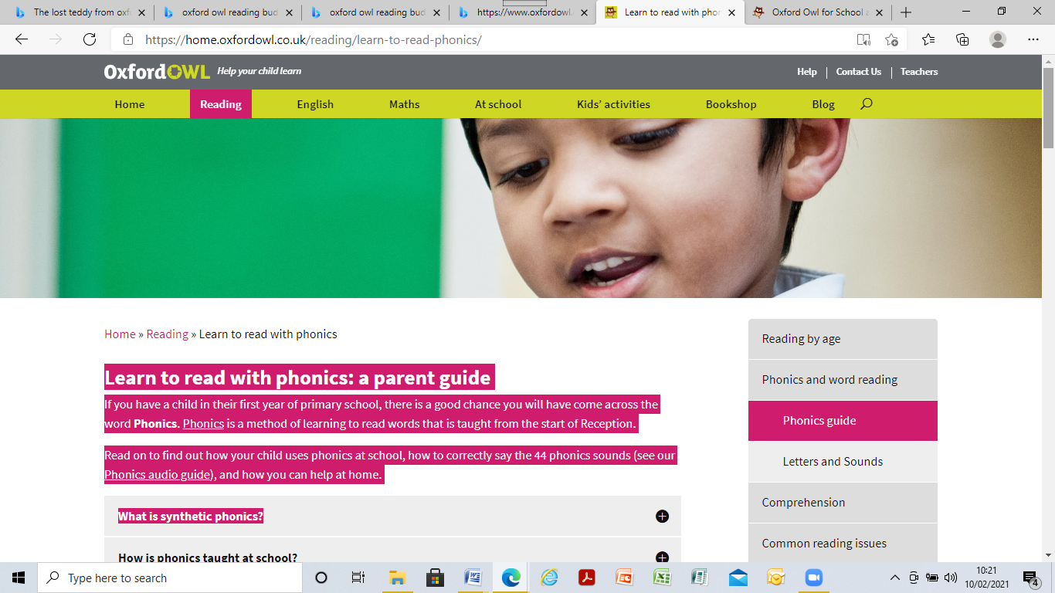

[Learn to read with phonics | Oxford Owl](https://home.oxfordowl.co.uk/reading/learn-to-read-phonics/)

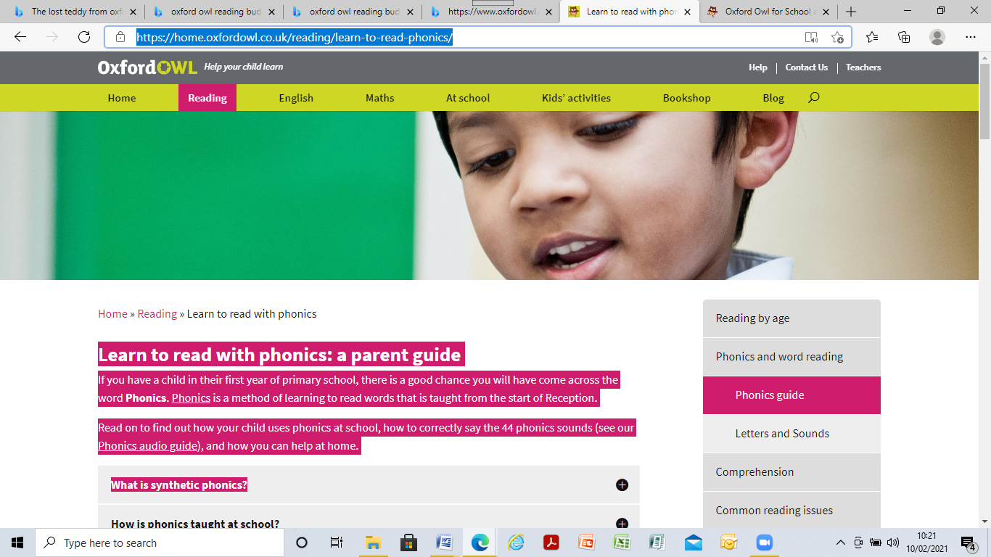

Information all about phonics and early reading plus how to say the sounds.

**Phonics Parent Guide**