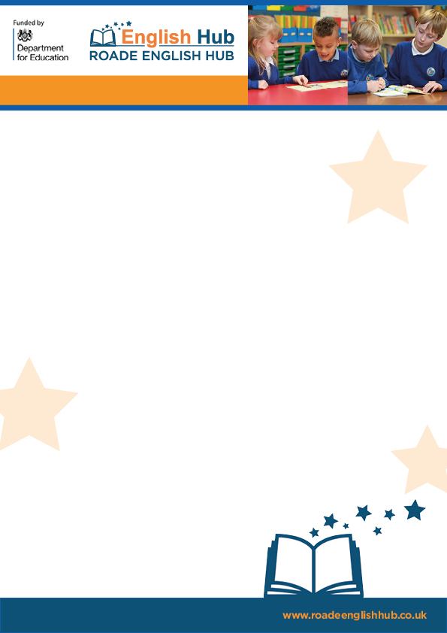

**Remote Phonics and Reading Lessons**

**Resource list**

**Guidance and review tools:**

[Review your remote education provision - GOV.UK (www.gov.uk)](https://www.gov.uk/government/publications/review-your-remote-education-provision)

**Overview**

Generally, some schools are doing a mixture of teacher led lesson input (recorded) or give children access to powerpoint, where they complete a task. Parental access from one place does makes things easier.

Other lessons are live, or recorded to be accessed later via their website.

Some schools set a timetable and tasks then do a remote daily zoom to check in and go over the answers, address misconceptions for the other curriculum areas.

Teachers can ask key children to stay on at the end or do a follow-up 1-1 check in or phone call.

General feedback and work completed is uploaded through a platform such as dojo, seesaw, google classroom, etc. Schools need to do what is appropriate for your context.

**Top Tips**

[Top Tips for Teaching Live Lessons | Mrs Mactivity](https://www.mrsmactivity.co.uk/top-tips-for-teaching-live-lessons/)

* Keep it simple!
* Familiar routine, need only pencil and paper.
* Rules!
* Be prepared.
* Visual stimulus, animated slides for power point- words sliding in for example.
* Be familiar with the technology. Mute, screen sharing, etc. Control the chat option, etc.
* Pace- thinking time for children to respond (count to 5 in your head).
* Gesture and point and sweep, colour- bold – ensure words can be clearly seen. Light can reflect on screens!
* Strategies
* 1. Model 1 or 2 – *make teaching points.*
* 2. Have a go *- ‘your turn’*
* 3. Together - *‘let’s check.’*
* Alternatively - ping pong, *‘I do’- ‘you do.’* Then *‘let’s check’* (together)
* Regular daily time.
* Short sharp focus.
* Chunk the content.
* Fun- play a game, or have a chat!
* Precise praise. Well done, good blending. Did you add the sound buttons? I like the way you made *‘igh’ a long sound button!’*
* Assessment:
* Recall method. My Turn Your Turn - ‘igh’ Write It. 1,2,3 Show Me to assess. Model and have another go if needed.
* Lots of recapping needed for GPC and blending.



**Remote Phonics and Reading Lessons**

**RWinc and Letters and Sounds Daily Phonic Lessons**

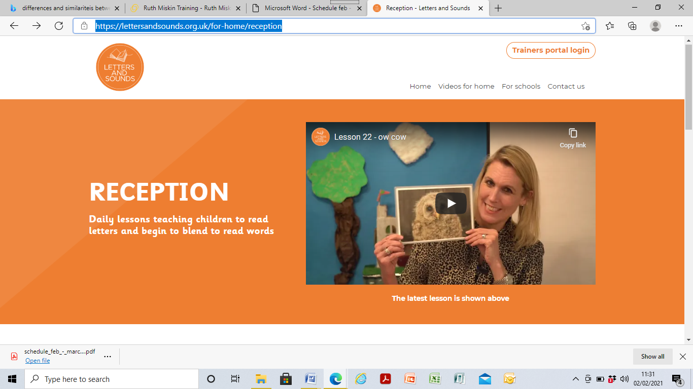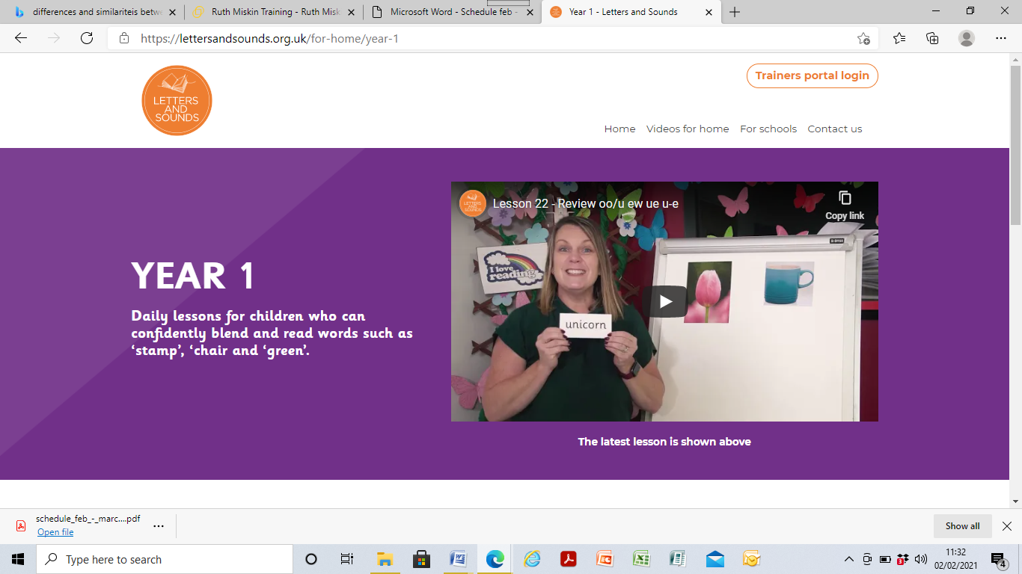

Letters and Sounds: [Home - Letters and Sounds](https://lettersandsounds.org.uk/)

Lesson are as follows - Reception 10.00am Year 1 - 10.30am and an extra practise at 11.00am

Read Write Inc: <https://www.youtube.com/watch?v=H9rGoXkmeyU>

**Story time**

On the booktrust website you can listen to live story times, share a story and enjoy!You can also upload stories to the website to be watched anytime that day.

You can also enjoy and chat to your class. Play a game- scavenger hunt, bingo and lots more.

Book Trust <https://www.booktrust.org.uk/books-and-reading/have-some-fun/>

Jackanory Junior <https://www.bbc.co.uk/programmes/b007t9wg>

Storytime online <https://www.storylineonline.net/>

**Shared reading of a decoable text**

Ensure texts are fully decodable and match your SSP.

[Free eBook library | Oxford Owl from Oxford University Press](https://www.oxfordowl.co.uk/reading-owl/find-a-book/library-page/)

[Collins Big Cat Ebook Library](https://collins.co.uk/pages/collins-big-cat-ebook-library)

<https://www.risingstars-uk.com/subjects/reading-and-ebooks/rising-stars-reading-planet/reading-planet-reception-and-ks1/rocket>

[Free eBook library – practise reading with phonics eBooks | Oxford Owl](https://home.oxfordowl.co.uk/reading/free-ebooks/)

[Bug Club Family (pearson.com)](https://www.pearson.com/international-schools/british-curriculum/primary-curriculum/bug-club-family.html)

**Full spelling and literacy lessons and units with quality texts**

[Oak National Academy (thenational.academy)](https://www.thenational.academy/)

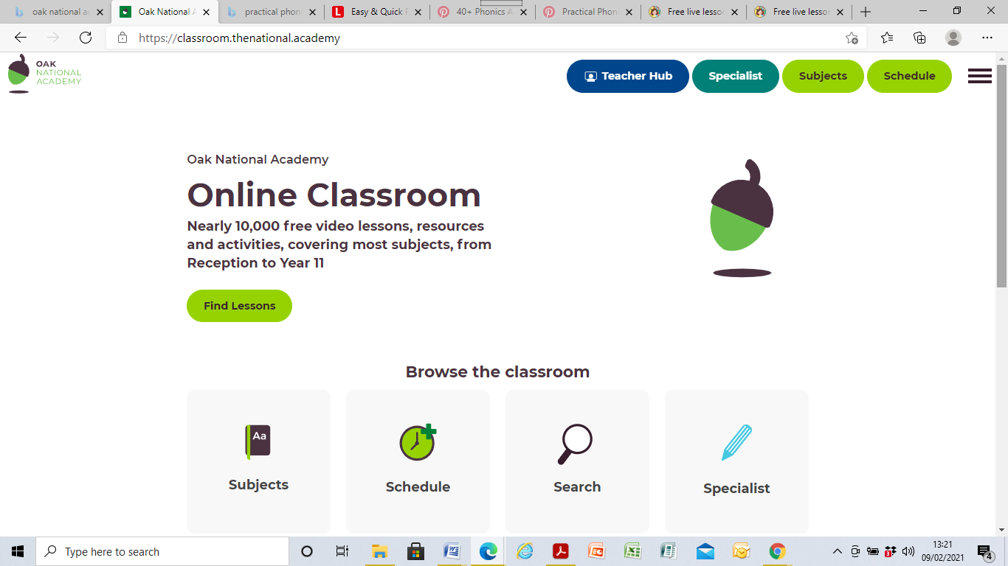

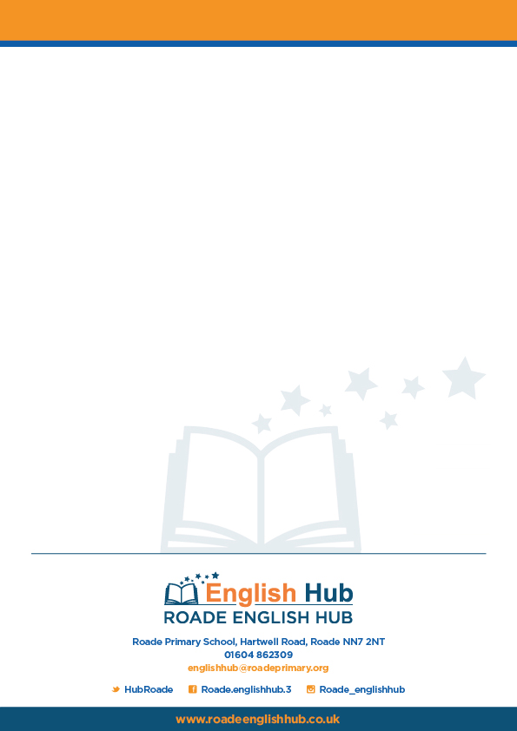

**Remote Phonics and Reading Lessons**

[Phonics | Mrs Mactivity](https://www.mrsmactivity.co.uk/downloads/category/phonics/) – Here you can access online lessons and printable home learning pack.

**Home Learning Packs**

[Free Home Learning Packs | Classroom Secrets](https://classroomsecrets.co.uk/free-home-learning-packs/)

[Phase 1 Home Learning Tasks - Phonics - KS1 Resources (twinkl.co.uk)](https://www.twinkl.co.uk/resource/t-l-5630-phase-1-home-learning-tasks)

[Download Phonics Resources | Mrs Mactivity](https://www.mrsmactivity.co.uk/downloads/category/phonics/page/2/)

LCP and Collins sell home phonic booklets.

Alphablocks: [Learn to Read | Phonics for Kids | Letter Teams - OO and OA - YouTube](https://www.youtube.com/watch?v=NN8gsI2FBQw)

ICT.games [Poop Deck Pirates - mobile friendly (ictgames.com)](https://www.ictgames.com/mobilePage/poopDeck/index.html)

[PhonicsPlay - Parent Information](https://www.phonicsplay.co.uk/parents)

[www.Readingeggs.co.uk](http://www.Readingeggs.co.uk)

Onwordshark: [Schools - Wordshark - Wordshark & Numbershark](https://www.wordshark.co.uk/wordshark/schools/)

[Teach Your Monster to Read: Free Phonics & Reading Game](https://www.teachyourmonstertoread.com/)

*Accessible, free and children can access independently.

*Tool for consolidation

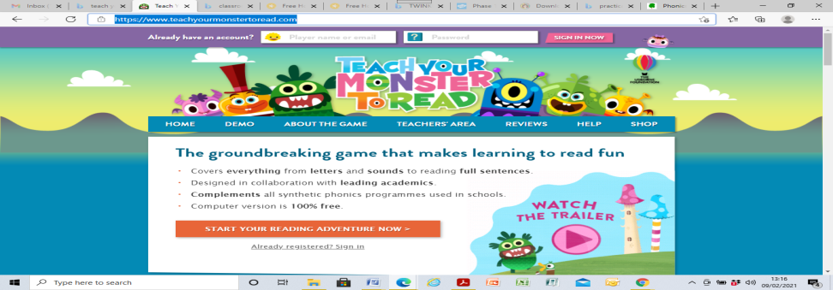

**Learning platforms to deliver lessons:**

Teams, zoom

Powerpoint, word- record and upload to website.

Sway

See-saw

Purple mash- have activities children complete and upload their work for teachers to check.

*Feedback: follow-up opportunities to check in on children’s progress to reward, praise and support as apt.

**Tricky words**

Phase 2

[Tricky Words and Sight Words Song - YouTube](https://www.youtube.com/watch?v=TvMyssfAUx0)

Phase 3

[Phase 3 Tricky Words Song Say Hello To - YouTube](https://www.youtube.com/watch?v=R087lYrRpgY)

Phase 4

[Phase 4 Tricky Words Song Sight Words Song for said, have, like, come, some, what, when - YouTube](https://www.youtube.com/watch?v=3NOzgR1ANc4)

Phase 5

[Phase 5 Sounds Song - YouTube](https://www.youtube.com/watch?v=YPW-ZkhRUPY)

Tricky words

Click these links to learn your tricky words:

[Tricky words | Phase 2 Phonics | Phonics song - BBC Bitesize](https://www.bbc.co.uk/bitesize/topics/zf2yf4j/articles/zdrd8xs)