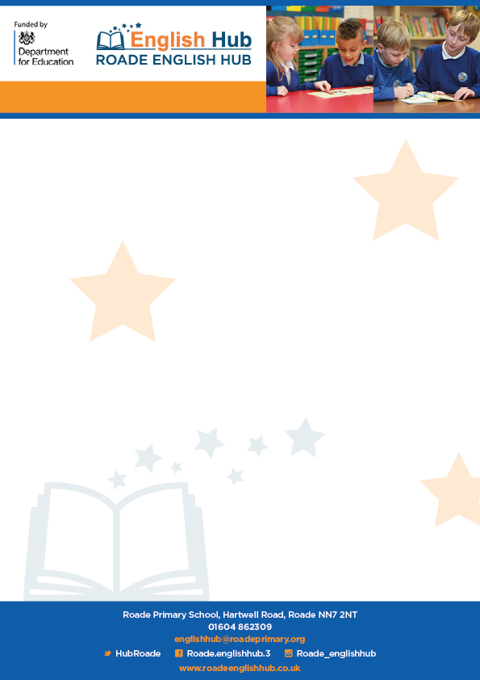

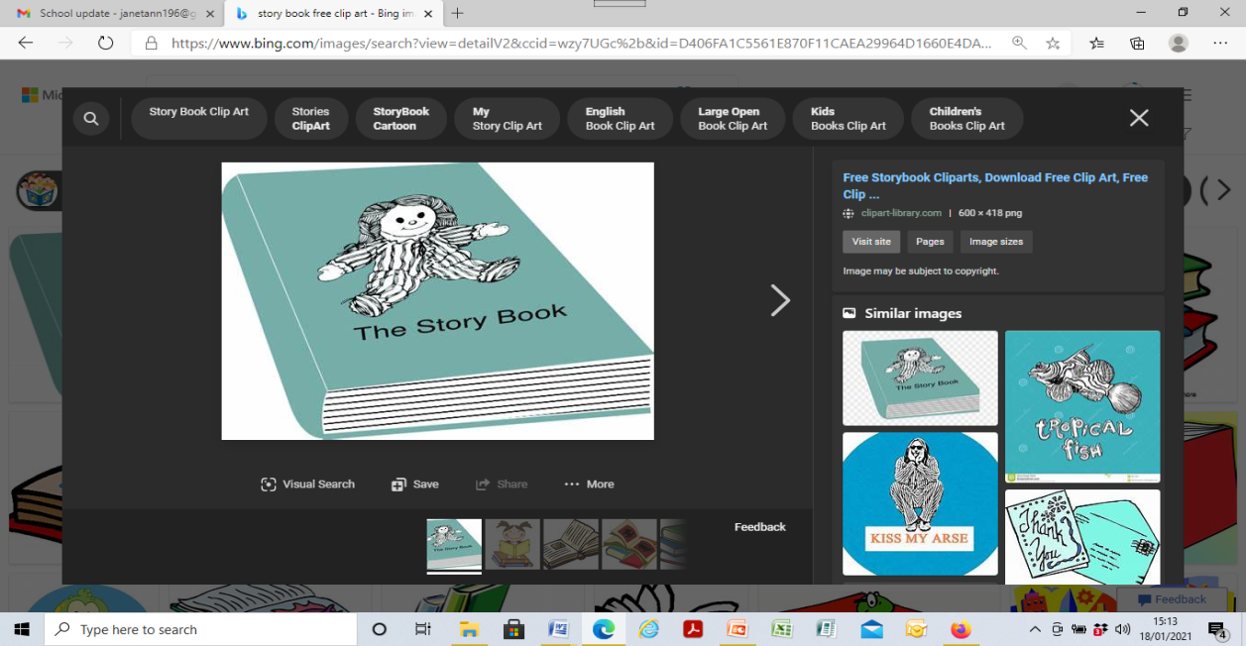

In addition to online remote lessons from RWinc and Letters and Sounds they have these resources

Letters and Sounds: [Home - Letters and Sounds](https://lettersandsounds.org.uk/)

Read Write Inc: <https://www.youtube.com/watch?v=H9rGoXkmeyU>

The Hub have also discovered these decodable e –books for home.

[Free eBook library | Oxford Owl from Oxford University Press](https://www.oxfordowl.co.uk/reading-owl/find-a-book/library-page/)

[Collins Big Cat Ebook Library](https://collins.co.uk/pages/collins-big-cat-ebook-library)

<https://www.risingstars-uk.com/subjects/reading-and-ebooks/rising-stars-reading-planet/reading-planet-reception-and-ks1/rocket>

[Free eBook library – practise reading with phonics eBooks | Oxford Owl](https://home.oxfordowl.co.uk/reading/free-ebooks/)

[Bug Club Family (pearson.com)](https://www.pearson.com/international-schools/british-curriculum/primary-curriculum/bug-club-family.html)

We have also discovered some excellent websites where stories are read to children -

Book Trust

<https://www.booktrust.org.uk/books-and-reading/have-some-fun/>

Jackanory Junior

<https://www.bbc.co.uk/programmes/b007t9wg>

Storytime online

<https://www.storylineonline.net/>

**Remote Learning Decodable Reading**